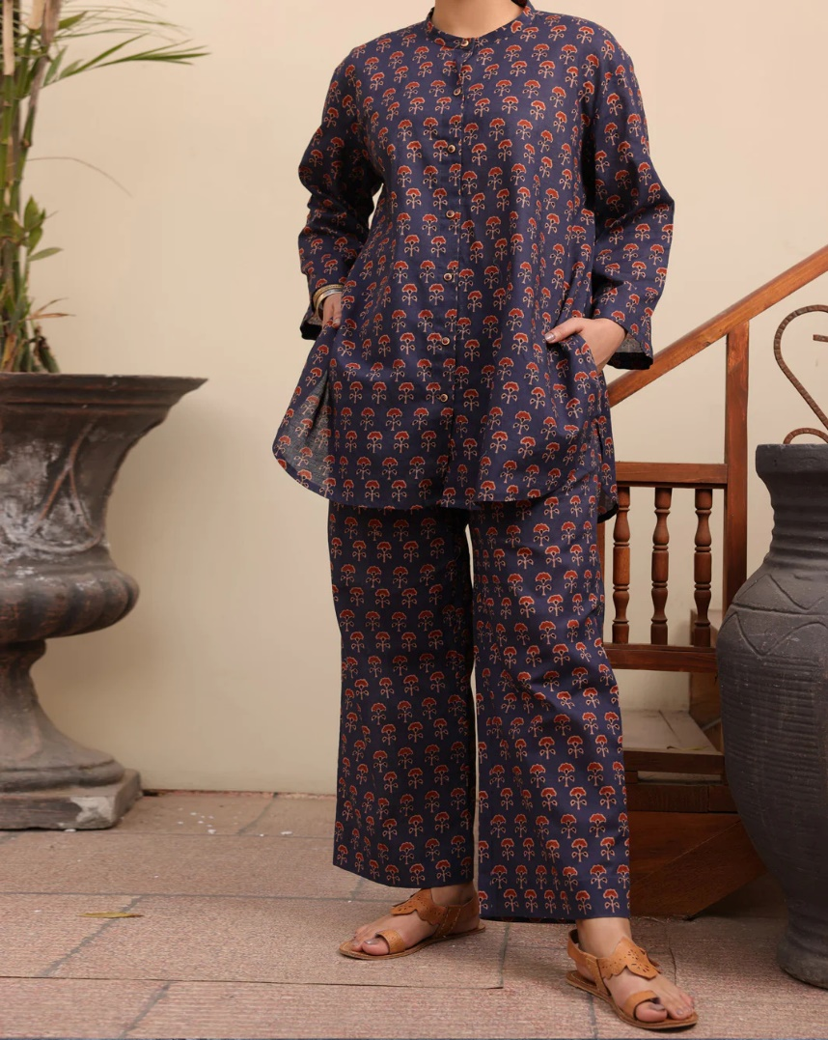­­

# MULTICOLOR CAMBRIC 2 PIECE STITCHED - ALP-2PS-LKS-1092

priceRs.2,970.00

ADDITIONAL INFO

|  |  |
| --- | --- |
| **Color** | Multicolor |
| **Pieces** | 2 Piece |
| **Fit Type** | — |
| **Fabric** | Cambric, |
| **Season** | — |
| **Disclaimer** | Due to the photographic lighting & different screen calibrations, the colors of the original product may slightly vary from the picture. |